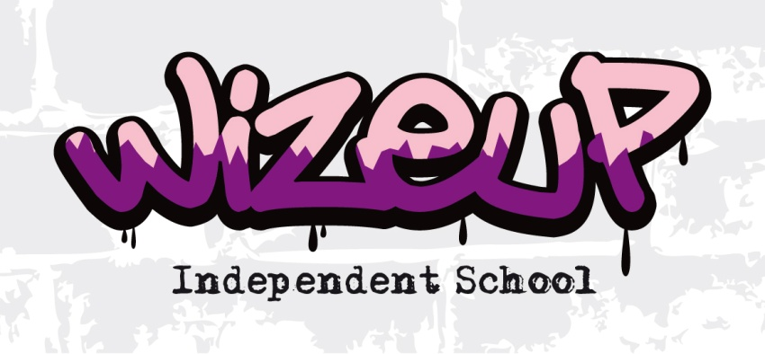

DBS Policy Statement
Date of Policy: September 2018.
Frequency of Review: Annually.
Date of Next Review: September 2019.

As an organisation using the Disclosure and Barring Service (DBS) Disclosure service to assess applicants’ suitability for positions of trust, Wize Up complies fully with the DBS Code of Practice and undertakes to treat all applicants for positions fairly. We undertake not to discriminate unfairly against any subject of a Disclosure on the basis of conviction or other information revealed.
Wize Up is committed to the fair treatment of its staff, potential staff or users of its services, regardless of race, gender, religion, sexual orientation, responsibilities for dependants, age, physical/mental disability or offending background.
We have a written policy on the recruitment and selection policy, which is made available to all applicants at the outset of the recruitment process.
We actively promote equality of opportunity for all with the right mix of talent, skills, and potential and welcome applications from a wide range of candidates, including those with criminal records. We select all candidates for interview based on their skills, qualifications, and experience.
All positions at Wize Up will require an Enhanced Disclosure, all application forms, job adverts and recruitment briefs will contain a statement that a Disclosure will be requested in the event of the individual being offered the position.
As an Enhanced Disclosure forms part of the recruitment process, we encourage all applicants called for interview to provide details of their criminal record at an early stage in the application process. We request that this information is sent under separate, confidential, cover to a designated person within Wize Up and we guarantee that this information is only be seen by those who need to see it as part of the recruitment process.
All positions related to working at Wize Up will involve contact with children and young people and is exempt from the Rehabilitation of Offenders Act 1974 and all subsequent amendments (England and Wales). For these positions you are not entitled to withhold information about police cautions, bind-overs, or any criminal convictions including any that would otherwise be considered ‘spent’ under the Act.

We ensure that all those in Wize Up who are involved in the recruitment process have been suitably trained to identify and assess the relevance and circumstances of offences. We also ensure that they have received appropriate guidance and training in the relevant legislation relating to the employment of ex-offenders, e.g. the Rehabilitation of Offenders Act 1974.
At interview, or in a separate discussion, we ensure that an open and measured discussion takes place on the subject of any offences or other matters that might be relevant to the position. Failure to reveal information that is directly relevant to the position sought could lead to withdrawal of an offer of, or termination of employment.
We make every subject of a DBS Disclosure aware of the existence of the DBS Code of Practice a copy of which is forwarded to the subject directly.
We undertake to discuss any matter revealed in a Disclosure with the person seeking the position before withdrawing a conditional offer of employment.
Having a criminal record will not necessarily bar you from working with us. This will depend on the nature of the position and the circumstances and background of your offences. For more information regarding DBS Disclosures please refer to https://www.gov.uk/government/organisations/disclosure-and-barring-service or should your query be more specifically related to Wize Up and this policy then please do not hesitate to contact us on 0208 859 9664.
Other policies, which relate to this policy, include the Child Protection, Staff Code of Conduct, Recruitment and Selection.

